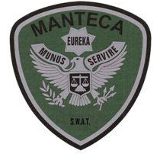MANTECA POLICE DEPARTMENT 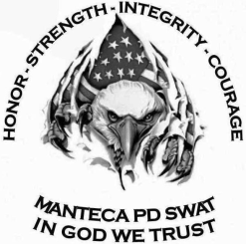 MEMORANDUM

TO: Team Commander Lt. P. Carmona

Assistant Team Leader Sgt. M. Ellis

FROM: Team Leader Sgt. J. Sweeten

DATE: January 8th, 2020

RE: S.W.A.T. Training on Jan. 8th  2020 (Rifle and Pistol Qualification, Team Movements)

On 01-08-2020, S.W.A.T. Operators from Manteca Police Department conducted at 10 hour training day focusing on weapon proficiency, weapon qualifications, weapon reloading and team movements. Today’s training was completed at two locations which included Manteca Police Department’s Detective Conference Room and our assigned firearms training range located in Ripon, CA. Detective Bonetti conducted a table top exercise at M.P.D. on theoretical team movement during a high risk search warrant. SWAT Commander, Lt. Paul Carmona was present for this portion of training. Topics of conversation included cover and concealment when making an approach to the front door of a residence from our armored vehicle and identifying individual operator responsibilities during the approach. Detective Bonetti described an ambush scenario and generated a conversation with operators on their perspective of the incident and identified areas of responsibility.

Following our team meeting and table top exercise, operators from Manteca Police Department responded to the Ripon Firearms Training Range where pistol and rifle qualification were completed. All operators present obtained a passing score for their marksmanship and weapon proficiency. *See results below. Our next 2020 weapons qualification for Q2 is scheduled for April 22. Additional training focused on two person movements from cover and/or concealment while bounding between buildings and vehicles. Operators were required to actively engage a threat while their partner moved between bounding locations.

Additional training focused on weapon reloading proficiency, magazine storage/placement on the S.W.A.T. uniform and weapon malfunctions. Firearms were cleaned at the range and equipment maintenance was performed. An open team discussion and a debriefing was conducted at the conclusion of the training day to identify any areas or improvement and to solidify practiced movements.

**MEMBERS PRESENT:**

|  |  |  |
| --- | --- | --- |
| S.W.A.T. Operator: | Pistol Qual. Score | Rifle Qual. Score |
| Bonetti, Jason | 96 | 96 |
| Hooten, Jeff | 94 | 94 |
| Eichel, Elliot | 98 | 94 |
| Stocks, Chris | 98 | 100 |
| Peters, Daniel | 90 | 96 |
| Brooks, Devin | 94 | 100 |
| Plascencia, Jose | 96 | 94 |
| Wise, Michael | 90 | 82 |
| Ellis, Mitch | 90 | 94 |
| Sweeten, Joshua | 92 | 84 |
| Rourick, Paul: Ripon P.D. was absent from training due to reduced RPD staffing. | 0 | 0 |