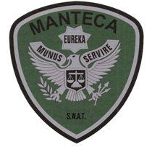MANTECA POLICE DEPARTMENT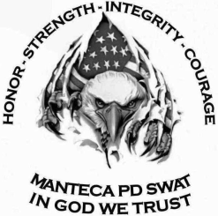 MEMORANDUM

TO: SWAT Team Leader Sgt. Sweeten

FROM: Detective Bonetti

DATE: January 23rd, 2020

RE: SWAT Training on January 22nd 2020 (Chemical Agents) 0600-1600

On Wednesday 01/22/20, the MPD SWAT team conducted annual CS (Chemical Agent) training. The classroom training took place at MPD in the conference room and physical training took place at the Livingston Police Department range and shoot house.

The first part of training was conducted in the conference room discussing the use of CS chemical agents. The discussion covered the type of chemical agent we use (CS), what LCT50 is, why it is important (use of force), the formula for determining the LCT, deployment methods, decontamination, and considerations for when and when not to use CS gas, (elderly, young children). Each member worked a mock chemical agent use plan and used the LCT form to determine the amount of chemical agent and the LCT.

The second part of the training day was conducted at the Livingston PD range and shoot house. This training focused on explanation of storage of masks, how to tactically apply the mask with a buddy and where the chemical agents are located. Operators were then exposed to the CS chemical agent and practiced how to effectively clear the mask after being exposed.

Each operator conducted live fire training with both rifle and pistol while wearing their masks to be familiar with the effect of shooting with masks on. Shooting drills were dynamic on the move with rifle and pistol reloads with transitions back and forth.

After live fire the entire team conducted mock entries and room clearing in the shoot house while wearing gas masks. There were several shoot – no shoot targets placed in different random rooms and proper room clearing methods were applied and discussed after each scenario. Operators started the room clearing with two operators at a time and worked the rooms multiple times. Next the groups cleared the rooms with three operators. Finally the groups cleared the room with the rest of the team.

**MEMBERS PRESENT:**

Team Leader Sgt. Sweeten

Asst. Team Leader Sgt. Ellis

Detective Bonetti

Detective Hooten

Detective Peters

Officer Stocks

Officer Plascencia

Officer Eichel

Officer Brooks

Officer Wise

Officer R. Smith