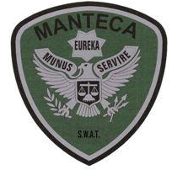MANTECA POLICE DEPARTMENT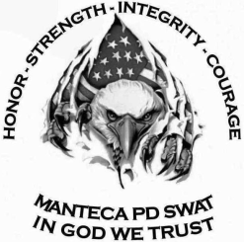 MEMORANDUM

TO: Team Leader Sgt.Sweeten

Asst. Team Leader Sgt. Ellis

FROM: Detective Bonetti

DATE: July 17, 2019

RE: S.W.A.T. Training for July 24th  2019

**TRAINING AGENDA:**

0700-0800: PT – Ripon Crossfit.

0900-0930: Team meeting – Manteca PD Det. Conf room

1000-1100: Classroom- Go over Active Threat Protocol, CQB video

1100-1200: Lunch

1230-1600: Shooting drills

1600-1700: Clean range, guns, go home.