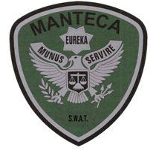MANTECA POLICE DEPARTMENT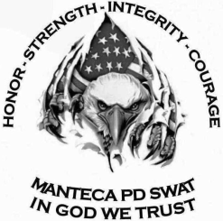 MEMORANDUM

TO: SWAT Team Leader Sgt. Sweeten

FROM: SWAT Assistant Team Leader Sgt. Ellis

DATE: August 18th, 2019

RE: SWAT Training on August 18th, 2019

Today’s training was focused on building clearing, entry and approach combat course and range qualification. Due to unforeseen criminal activity, those SWAT Operators in a detective role were not authorized to attend today’s training. This information was relayed to me at approximately 1500 hours on August 17th. Because of the low number of SWAT Operators able to attend training I had to modify our training outline.

On this day we spent most of our time at the range working on moving and shooting / checked zero on our SWAT rifles / long range pistol marksmanship / rifle marksmanship from the 50 yard line. We also conducted a test of low angle of deflection off of vehicle body parts (hood and doors). We also conducted the angle of deflection when shooting through windshields. Weapon maintenance and cleaning concluded our day.

**MEMBERS PRESENT:**

Officer Stocks

Officer Eichel

Officer Brooks

Sgt. Ellis