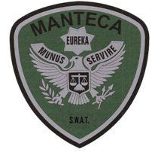MANTECA POLICE DEPARTMENT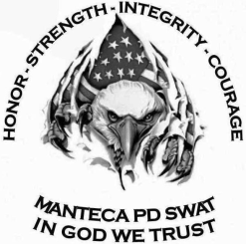 MEMORANDUM

TO: SWAT Team Leader Sgt. Sweeten

FROM: Officer Plascencia

DATE: October 23rd, 2019

RE: SWAT Training on October 23rd,2019

**Training Summary:**

On 10/23/19 the Manteca-Ripon S.W.A.T. Team conducted training. For P/T was conducted at the Boys and Girls Club in Manteca for approximately 90 minutes. P/T included a warmup, cool down, and calisthenics. Building searches were conducted in full gear with the inclusion of evacuation tactics. Shooting was also conducted at the range in full gear with the inclusion of evacuation tactics.

**Building Searches:**

Building searches were conducted at the Firehouse at the Sharpe Army Depot. We worked on slow deliberate clearing. We worked in groups of three to maintain coverage on the hallway and to clear each room. Additional groups were deployed from the point of entry, to clear additional rooms and areas. The searches were slow and controlled, maintaining coverage at all times in un-cleared areas. Additional topics listed below were covered:

* Holding ground for barricaded suspects
* Controlled evacuation
* Noise discipline
* Slow searching

**Range Training:**

Range training was conducted in full gear. Live fire move-and-shoot drills were conducted with rifles, in relation to evacuation tactics. Multiple rounds were fired by each operator on the threat command. Speed shooting drills were also conducted with elevated heart rates.

**Members Present:**

**Sgt. Mitch Ellis**

**Det. Jason Bonetti**

**Officer Devin Brooks**

**Officer Chris Stocks**

**Officer Jose Plascencia**

**Det. Daniel Peters**