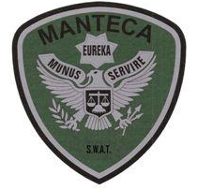MANTECA POLICE DEPARTMENT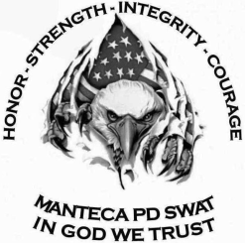 MEMORANDUM

TO: Training File, via Chain of Command

FROM: Detective Peters

DATE: December 13, 2019

RE: Training Completed December 13, 2019

**Training Summary:**

On 12/13/2019, the Manteca-Ripon SWAT Team conducted training. A cross-fit style workout was completed by the team for physical training. At the conclusion of the workout the team went to Great Wolf Lodge were we conducted a threat assessment. After lunch, the team conducted tabletop exercises.

**Threat Assessment of Great Wolf Lodge included:**

**Information obtained included:**

* Surveillance system details
* Alarm system details
* Number of employees working per shift
* Contact information
* Key holder information
* Fire box information
* Access points/type of doors/fortification
* Location of access points
* Roof access
* Company emergency procedures
* Armed employees
* Hazards
* Layout
* Special Equipment needed
* Sniper hide locations

**Tabletop exercises included:**

* Surround and callout
* Dynamic entry
* Snipper deployment
* Use of BATT

**MEMBERS PRESENT:**

TL Sgt. Sweeten, ATL Sgt. Ellis, Det. Peters, Det. Bonetti, Det. Hooten, Det. Bright, Ofc. Plascencia, Ofc. Brooks, Ofc. Stocks, Ofc. Eichel,